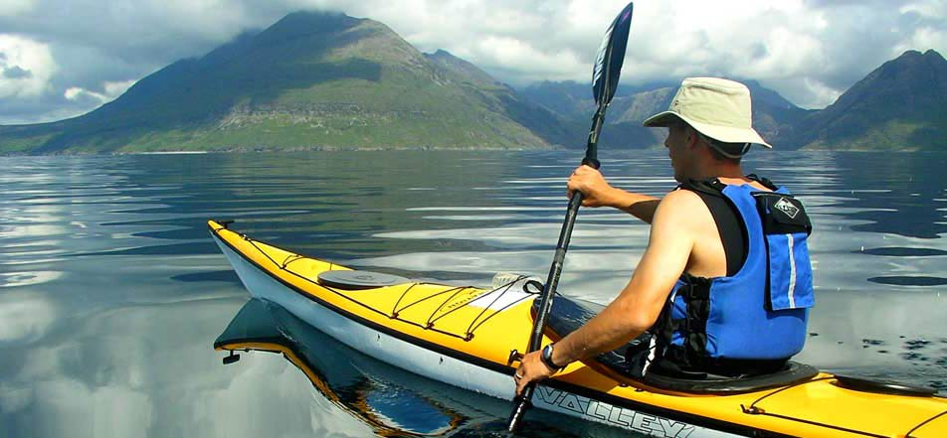Kayaking Basics

FREE

Class

***Class runs from 2pm to 4pm. We will cover basic paddling strokes and what to do when you flip over.***

**YOU MUST BRING ALL OF YOUR OWN GEAR: KAYAK, PADDLE, PFD, WHISTLE,**

Also bring:

* Sunscreen, sunglasses, and a hat
* Wear clothing you plan to get wet in and your feet must have shoes or sandals on them
* Water bottle full of water

**Ages 13-15** (must be accompanied by an adult**), 16-17** (must have adult sign a waiver if the parents aren’t staying). **18 and up** can sign the waiver yourself.

CALL THE BOAT HOUSE BETWEEN 10am and 5:30pm at

**704-984-6160** or visit the boathouse in person to register.